Lab Assignment 6 - Complex SELECT statements

## Instructions

1. Answer the below question in the boxes.
2. Please submit the assignment through TalentLabs Learning System.

## Open the Movies database

Follow the step illustrated in Chapter 3 to open the Movies database using DB Browser for SQLite. You should see 5 tables in the database.

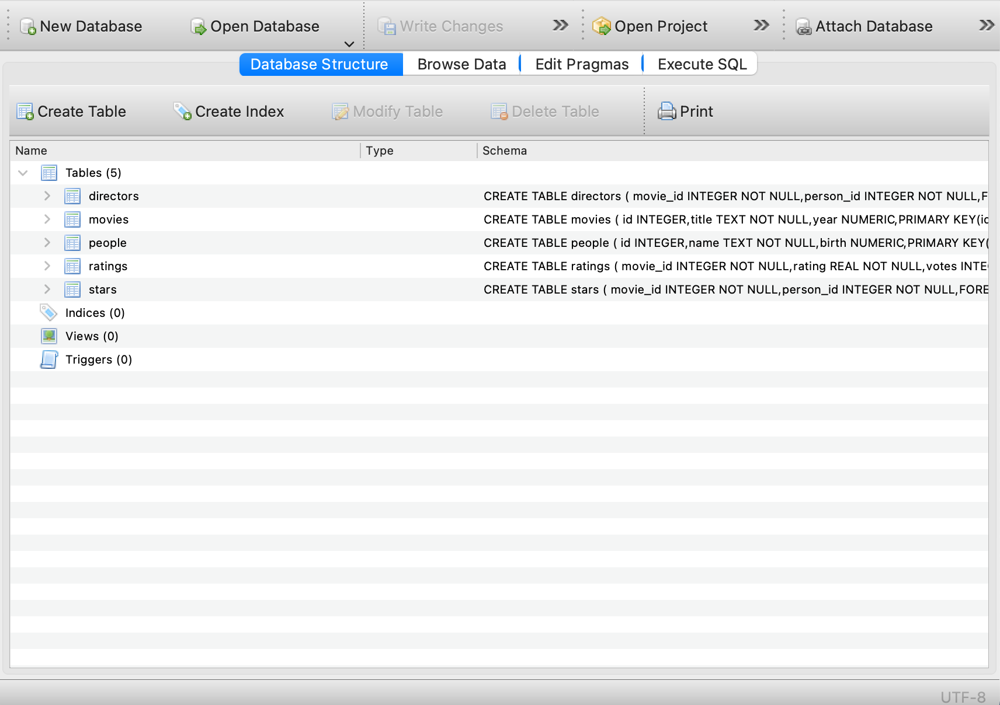

## 

## Understanding the database

1. Study the table schema and the data in the “people” and “directors” table and describe the relation between the tables “people” and “directors”

|  |
| --- |
| The “people” table will be binding with “directors” table which “people” id was located as the “directors” person_id. |

1. Study the table schema and the data in the “movies” and “directors” table and describe the relation between the tables “movies” and “directors”

|  |
| --- |
| The “movies” table will be binding with “directors” table which “movies” id was located the “directors” movie_id. |

## Query Exercises

1. Write a SQL query to obtain the movie_id who is directed by “Joris Ivens” without using WITH keyword

**Expected Output:** a table with a single column for the movie_id of the director’s movie.

|  |
| --- |
| SELECT movie_id FROM directors WHERE person_id IN (SELECT id FROM people WHERE name= 'Joris Ivens') |

1. Write a SQL query to obtain the movie title who is directed by “Joris Ivens”  
   **Expected Output:** a table with a single column for the movie title of the director’s movie.

|  |
| --- |
| WITH  Name_Joris AS  (SELECT id FROM people WHERE name = 'Joris Ivens'),  movieID AS  (SELECT movie_id FROM directors WHERE person_id IN Name_Joris)  SELECT title FROM movies WHERE id IN movieID |

1. Organize and rewrite the SQL query of Q1 using WITH keyword  
   **Expected Output:** The SQL query in WITH keyword

|  |
| --- |
| WITH mv_id AS  (  SELECT id FROM people WHERE name = 'Joris Ivens'  )  SELECT movie_id FROM directors where person_id IN mv_id |

1. Write a SQL query to show each person’s name and whether the person is born before 1970, born in 1970, born after 1970  
   **Expected Output:** The SQL query fulfilling the required data

|  |
| --- |
| SELECT name,  CASE  WHEN birth < 1970 THEN 'born before 1970'  WHEN birth > 1970 THEN 'born after 1970'  WHEN birth = 1970 THEN 'born in 1970'  ELSE NULL  END AS born_year FROM people |

1. Write a SQL query to count the number of people in the “people” table by each birth year.  
   **Expected Output:** The SQL query fulfilling the required data. Note that having the NULL birth year on the query result is normal.

|  |
| --- |
| SELECT birth, COUNT(*) FROM people GROUP BY birth |

1. Write a SQL query to count the number of directors by each birth year. Only the years with more than 500 directors born are interested.  
   **Expected Output:** a table with two columns for the birth year and count of directors.

|  |
| --- |
| WITH  directorsID AS  (SELECT DISTINCT person_id FROM directors)  SELECT birth,COUNT(*) AS count FROM people WHERE id IN directorsID AND birth IS NOT NULL  GROUP BY birth HAVING count>500 |

**- End of Assignment -**